
Name: ____________________ My Target: _____ / 50 ____%

Year 10 History

Key Focus: The Modern World and Australia /50
Cartoon & Source Analysis

* Complete all tasks.
* Remember to refer to the sources within your text.
* Working time 45 minutes; 5 minutes reading time

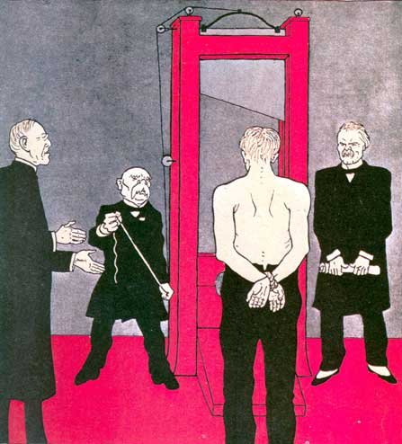
Source 1

A cartoon published in the German magazine Simplissimus, June 1919

The Big 3 leaders shown in the cartoon are (left to right) Wilson of the USA, President Clemenceau of France and Prime Minister Lloyd George of Britain. They are standing around a guillotine (an old French execution apparatus) and are focusing on a figure before them.

1. Using the date of Source 1 as a prompt and also your knowledge of history, place this

source in its historical context, meaning name the event this illustrated situation is meant

to represent. .

_____________________________________________ (1 mark)

2. The drawn figure facing ‘Wilson, Clemenceau and George’ is meant to be a

representation of what?

_____________________________________________ (1 mark)

3. Using your historical knowledge, state the cause of this historical event.

_____________________________________________ (1 mark)

4. Using your historical knowledge, explain the effects of this historical event.

_______________________________________________________________________________________________________________________________________________________________________________________________________________________________________________________________________________________________________________________________________________________________________________________________________________________________________________________________________________________________________________________________ (4 marks)

Source 2 Source 3
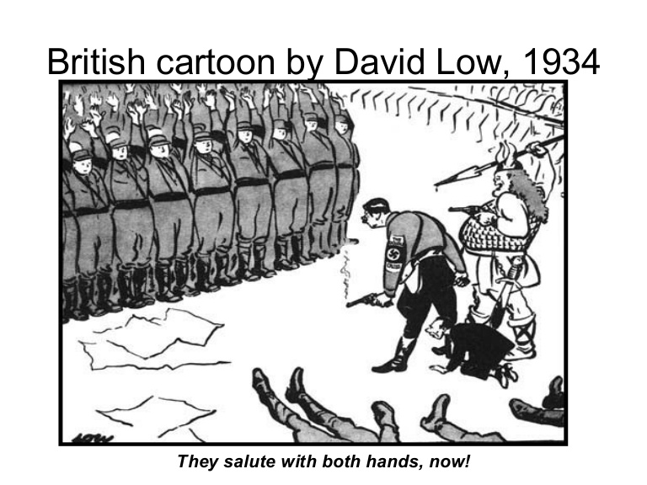
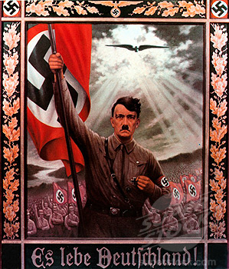

A Nazi Propaganda poster, 1936

It reads ‘Long Live Germany’

5. State the first and last name of the person shown in both Source 2 and Source 3.

____________________________________________ (1 mark)

6. State if Source 2 is a primary or secondary source.

_____________________________________________ (1 mark)

7. What is the message of Source 2 – explain what the illustrator is trying to get you to

think, believe or feel? Use examples from the source in your response.

____________________________________________________________________________________________________________________________________________________________________________________________________________________________________________________________________________

(2 marks)

8. What is the message of Source 3 – explain what the illustrator is trying to get you to

think, believe or feel? Use examples from the source in your response.

____________________________________________________________________________________________________________________________________________________________________________________________________________________________________________________________________________

(2 marks)

9. Compare the messages of Source 2 and Source 3 – identify the similarities between

two sources.

____________________________________________________________________________________________________________________________________________________________________________________________________________________________________________________________________________

(2 marks)

10. Contrast the messages of Source 2 and Source 3 – identify the differences between two sources.

____________________________________________________________________________________________________________________________________________________________________________________________________________________________________________________________________________

(2 marks)

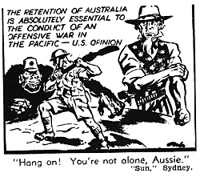
Source 4

11. Which three (3) countries are represented in Source 4? Explain in your response why

you believe these countries are represented. Remember to refer to the source.

______________________________________________________________________________________________________________________________________________________________________________________________________________________________________________________________________________________________________________________________________________________________________________________________________________________________________________________________________________________________________________________________________________________________________________________________________________________________________________________________________________________________________________________________________________________________________________________________________________________________________________________________________________________________________________________________________________________________________________________________________________________________________________________________________________________________________________________________________________________________________________________________________________________________________________________________________________________________________________________________________________________________________________________________________________________________________________________________________________________________________________________________________________________________________________________________________________________________________________________________________ (6 marks)

Source 5

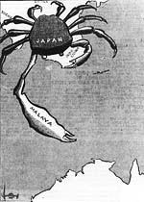

12. Using the information in Source 4 and Source 5 as a prompt and also your knowledge

of history, place these sources in their historical context, meaning name the event these

illustrated situations are meant to represent. In this response, include who, what, when,

where, and then go on to identify the causes and the effects.

__________________________________________________________________________________________________________________________________________________________________________________________________________________________________________________________________________________________________________________________________________________________________________________________________________________________________________________________________________________________________________________________________________________________________________________________________________________________________________________________________________________________________________________________________________________________________________________________________________________________________________________________________________________________________________________________________________________________________________________________________________________________________________________________________________________________________________________________________________________________________________________________________________________________________________________________________________________________________________________________________________________________________ (6 marks)

Source 6

13. State the date of the ‘Fall of Singapore’.

__________________________________________________ (1 mark)

14. Gona is located in what country?

___________________________________________________ (1 mark)

15. Approximately how long is the Kokoda Track?

____________________________________________________ (1 mark)

16. State the name of the largest and most important town in Papua New Guinea.
______________________________________________________ (1 mark)

17. The first of many air raids on Darwin took place on what date?

______________________________________________ (1 mark)

18. Pearl Harbour was a naval base for which country?

________________________________________________ (1 mark)

19. Explain how Source 6, Source 5 and Source 4 are interconnected. Provide specific examples from the three sources to explain the connection.
________________________________________________________

________________________________________________________

________________________________________________________

________________________________________________________

________________________________________________________

________________________________________________________

________________________________________________________

________________________________________________________

________________________________________________________

________________________________________________________ (4 marks)

Source 7

20. What does ABS stand for? (1 mark)

_________________________________________________

21. What does P.O.W stand for? (1 mark)

________________________________________________________

22. State the percentage of Army members killed as shown in Source 7.

______________________ (1 mark)

23. State the percentage of Prisoners of War who were part of the Air Force as shown in Source 7.

_______________________ (1 mark)

24. State the percentage of Air Force members who were recorded as missing out of the total recorded for All Services.

______________________ (1 mark)

25. Calculate the total number of people who were killed, wounded and injured for All Services.

_________________________ (1 mark)

26. Calculate the total number of people in the Navy and Air Force who were wounded or injured.

___________________________ (1 mark)

27. State whether Source 7 is an example of Primary data or Secondary data.

__________________________________________________________ (1 mark)

28. Suggest one reason why the Army had the largest number of Prisoners of War. Refer to Source 7 to support your response.

________________________________________________________

________________________________________________________

________________________________________________________

________________________________________________________

________________________________________________________

________________________________________________________

________________________________________________________ (3 marks)

End of paper

